Accommodations and Alternatives to the Standard Examinations
Among the requirements to be “certified ready to be examined for ordination” as a teaching elder in the Presbyterian Church (U.S.A.) is the presentation of examination materials and evaluations showing satisfactory completion of tests in the areas of Bible Content, Biblical Exegesis, Theological Competence, Church Polity, and Worship and Sacraments (G-2.0607d). The Book of Order, however, also recognizes that while competence in these areas is necessary for those who exercise the responsibility for fulfilling the functions of a teaching elder, the standard written examinations may not be appropriate means for demonstrating every individual’s competencies in these areas. It is important, then, for presbytery committees to be familiar with both the range of accommodations permitted by the Presbyteries’ Cooperative Committee on Examinations for Candidates (PCC) within the standard examination process and the possibilities and means for approving alternative means of demonstrating ministry competency available through Book of Order provisions (G-2.0610).

Foundational principles of the standard exams
It is helpful to begin by considering the role of the standard examinations in the overall process of preparation for ministry in the PC(USA). During the 1960s and 70s, concerns were raised across the church that some candidates for ministry were being assessed inequitably by differing presbyteries. Some candidates were perceived as receiving preferential treatment, whereas other perhaps less-known or less-connected candidates were held to much stricter standards. The exams were developed in part as “blind review” by members of other presbyteries as to the candidates’ competency in the areas of examination. A second key feature of the ordination exams was that they were to serve a different purpose than examinations in seminary courses. Rather than following the model of comprehensive exams required in some degree programs that test mastery of academic disciplines, these exams were intended to assess a person’s “readiness to begin ministry.” They generally accomplish this by use of a “case study” approach requiring the demonstration of what one study of clergy education called “pastoral imagination.” That is to say, they were to assess the ability to apply academic training to situations such as occur in congregational ministry.
It is important, then, that the exams are evaluated by future peers in ministry—both ruling elders and teaching elders engaged in the ministries of Word and Sacrament. Straightforward academic assessments in these areas were available in the grades by professors recorded in seminary transcripts. The ordination examinations provide assessment by ministry practitioners of readiness to begin ministry. Any assessment of competency considered by a presbytery, then, needs to seek to maintain these essential features: a review of readiness to begin ministry by future colleagues in that ministry not previously engaged in the candidate’s preparation.

Special accommodations to the exams
For pragmatic reasons related to the fact that the exams are given to literally hundreds of candidates each year, they have been designed as written examinations that can be evaluated by readers. Nevertheless, there are a variety of special accommodations that can be authorized within this standard examination process. For example, all the examinations are offered in English, Korean and Spanish, and evaluated by ruling and teaching elders fluent in those languages. Additionally, it is possible for a presbytery to request that a candidate be granted permission to write responses to the questions in other languages. For the request to be approved, the language must represent a sufficiently large community that ruling and teaching elders fluent in the language can be identified while preserving the principle of “blind review.” Policies for the standard exams, however, do not permit the translation of the questions into any other languages, nor can a candidate’s responses be translated from another language into English. These requirements are necessary to assure the consistency of the exams and that the evaluations are based solely upon the candidate’s own work.
Other accommodations can be made within the standard exams to address issues related to physical disability or learning disorders, so long as they are possible within the structural constraints of the examination. What are those “structural constraints”? In most instances this requires that the exam must result in a written response to the questions that can be evaluated without further comment or clarification by the candidate. However, beginning in July 2015 the PCC is also providing a structure to integrate an oral component into the Exegesis, Polity, Theology, and Worship exams as a special accommodation. The presbytery’s committee may authorize these accommodations based on their knowledge of the candidate and without a formal action by the presbytery itself.
Here are some examples of such special accommodations:
- Candidates with reading or language processing difficulties may be provided with extended time beyond the two hours allowed for the Bible Content Examination, limited to no more than one extra hour for a total of three hours to complete the test. Extensions beyond that tend to be counterproductive as they increase test taker fatigue. Please be aware, however, that PCC policies do not permit extensions of time for the nine-hour examinations in Polity, Theology, and Worship and Sacraments or the multi-day Exegesis exam. The time limits for the Polity, Theology, and Worship exams are designed to provide time for breaks, reflection, and proofreading of responses over roughly the span of a typical workday. The structure of the Exegesis exam includes the need to balance other responsibilities over the five-day examination period just as one must manage time and competing responsibilities when preparing sermons and Bible studies in the context of parish ministry.
- Some candidates with attention-deficit disorders have received permission to take the Bible Content Examination in a “distraction-reduced” setting. Working with testing site proctors or a special proctor if necessary, the exam would be administered in the best possible setting with the fewest distractions. In making these arrangements, care must be maintained to preserve the elements of a proctored testing environment. Consequently, candidates may not request taking the exams in isolation. Since the exams in the areas of Exegesis, Polity, Theology, and Worship are not taken under a proctor’s supervision, candidates are free to choose whatever setting they find most conducive to their work.
- Less common but still possible accommodations include having a proctor read the test questions aloud for candidates with either extreme forms of dyslexia or visual impairment. The person reading the test questions can repeat all or part of the questions as often as the candidate desires, but is not permitted to interpret or define any of the words in the questions or to provide any other assistance in either understanding what the question requires or crafting a response.
- Similarly since handwritten exams are no longer accepted, a candidate who has difficulty keyboarding responses may use speech recognition software to transcribe verbal responses into written form. Again, this accommodation does not include the translation from one language to another, nor does it permit any editorial assistance or review by a writing specialist. The final written response must be exclusively the candidate’s work. Candidates who use speech recognition software should take care to preserve sufficient time to review the transcription for accuracy.
As previously mentioned, in response to a referral from the General Assembly the PCC now also provides a means whereby presbyteries may request a special accommodation to integrate an oral component as part of the exams in the areas of Exegesis, Polity, Theology, and Worship. Presbyteries may authorize this accommodation when there are circumstances known in advance that make it clear that the test taker may need to comment or elaborate upon written responses. Such circumstances could include written language processing issues such as dyslexia or dysgraphia, individuals whose primary language is not among those in which the exams are offered (English, Korean, or Spanish), etc. In order to protect the integrity of the assessment process, the PCC requires specific administration processes to assure that any oral examination phase does not permit the candidate to correct errors in initial responses by redirecting them in fundamentally different ways based on comments from either the readers who evaluate the online submission or the oral component examiners, or create an opportunity for the test taker to be coached to a stronger answer through leading questions from the examiners. By authorizing this special accommodation, both the candidate and the presbytery entity overseeing the preparation process (CPM) would be committing to the following:
- The CPM appoints a panel of at least three oral examiners who are either ruling or teaching elders, preferably with experience as readers of the standard examinations.
- The candidate takes the standard examination(s), with any other special accommodations approved by the CPM, and those exams then undergo the usual evaluation process.
- On the morning the exam results are released, the oral examiners meet to review together both the candidate’s responses and the readers’ evaluations, and to formulate their own questions based upon both the responses and the evaluations.
- Following their review, the oral examiners meet with the candidate for the oral review phase (either the same morning or during the afternoon of the day the results are released, depending upon the number of exam areas for which the special accommodation was granted). This oral examination phase must be conducted regardless of whether the readers had found the exam “Satisfactory” or “Unsatisfactory.”
- Up to one (1) hour is permitted for oral review of each exam. Either responding directly to the readers’ comments or to questions from the oral examiners, the candidate elaborates or comments on the responses provided. During this oral phase, a candidate is permitted to explain the reasons for particular citations from the Book of Order, The Book of Confessions, or other resources provided as part of required responses, but the test taker is not permitted to substitute alternative citations for them. A candidate may, however, suggest further citations that would serve to clarify or support lines of argument already provided in the written responses. A candidate may also elaborate on points in the written response that he or she believes were either overlooked or misunderstood by the reader(s). The candidate will also be required to respond to any questions from the oral examiners even if those questions are unrelated to issues or concerns raised in the reader evaluations.
- At the conclusion of the hour, the oral examiners meet separately from the candidate to deliberate and then vote on whether to “sustain” the readers’ evaluation. This action is, again, required regardless of whether the readers had found the exam “Satisfactory” or “Unsatisfactory.” Thus, it would be within the oral examiners prerogative to recommend that an “Unsatisfactory” evaluation be set aside in favor of a “Satisfactory” one, or that a “Satisfactory” evaluation be set aside in favor of an “Unsatisfactory” one. A majority vote of the three oral examiners determines their recommendation.
- The oral examiners will then notify the candidate, the CPM, and the PCC (through the Manager for Preparation for Ministry in the Office of the General Assembly) of their recommendation.
  - If they sustain the readers’ initial evaluation, then that result is finalized.
  - If their recommendation is that the readers’ evaluation should not be sustained, they must file with the PCC a written explanation of their rationale providing specific references to either the candidate’s written or oral responses in support of their recommendation. This report must be filed within 48 hours of the close of the oral examination phase or phases (if there is more than one examination area). The chair of the PCC task group for the examination area (or the chair’s designated task group member) will review the candidate’s written responses, the readers’ evaluations, and the report from the oral examiners. The PCC member reviewing all these materials will determine whether or not to concur in the oral examiners’ recommendation or to sustain the original evaluation of the readers. The decision by the PCC task group chair or designated member will determine the final result of each examination.
- A task group chair’s decision (or that of the task group member designated to review the materials) is subject to appeal only to the PCC Executive Committee, and must otherwise comply with all other requirements for the appeal of examination results.
Because of the nature of the questions on the Bible Content Examination, a special accommodation for inclusion of an oral component to that test is not available.

Alternative means of assessing competencies
Even with these types of special accommodations, there will be some candidates for whom the standard examinations will not provide an appropriate opportunity to demonstrate their ministry competence and readiness. The Book of Order is clear that the examinations may not be waived (G-2.0610). They assess core competencies that we believe are essential to properly fulfill the responsibilities of a teaching elder engaged in ministries of the Word and Sacrament. But a presbytery may approve alternative means of demonstrating these competencies when they believe there are “good and sufficient reasons” for doing so. Such alternative means are best considered only once the candidate has fulfilled all other requirements to be certified ready for examination for ordination, pending a call, and the presbytery’s committee believes the candidate would pass final assessment were it not for the standard exam requirements.
So when should a presbytery explore alternative means of assessment? As a general rule, presbyteries may want to investigate this possibility when an otherwise qualified candidate has failed to satisfactorily complete an examination area after two attempts.
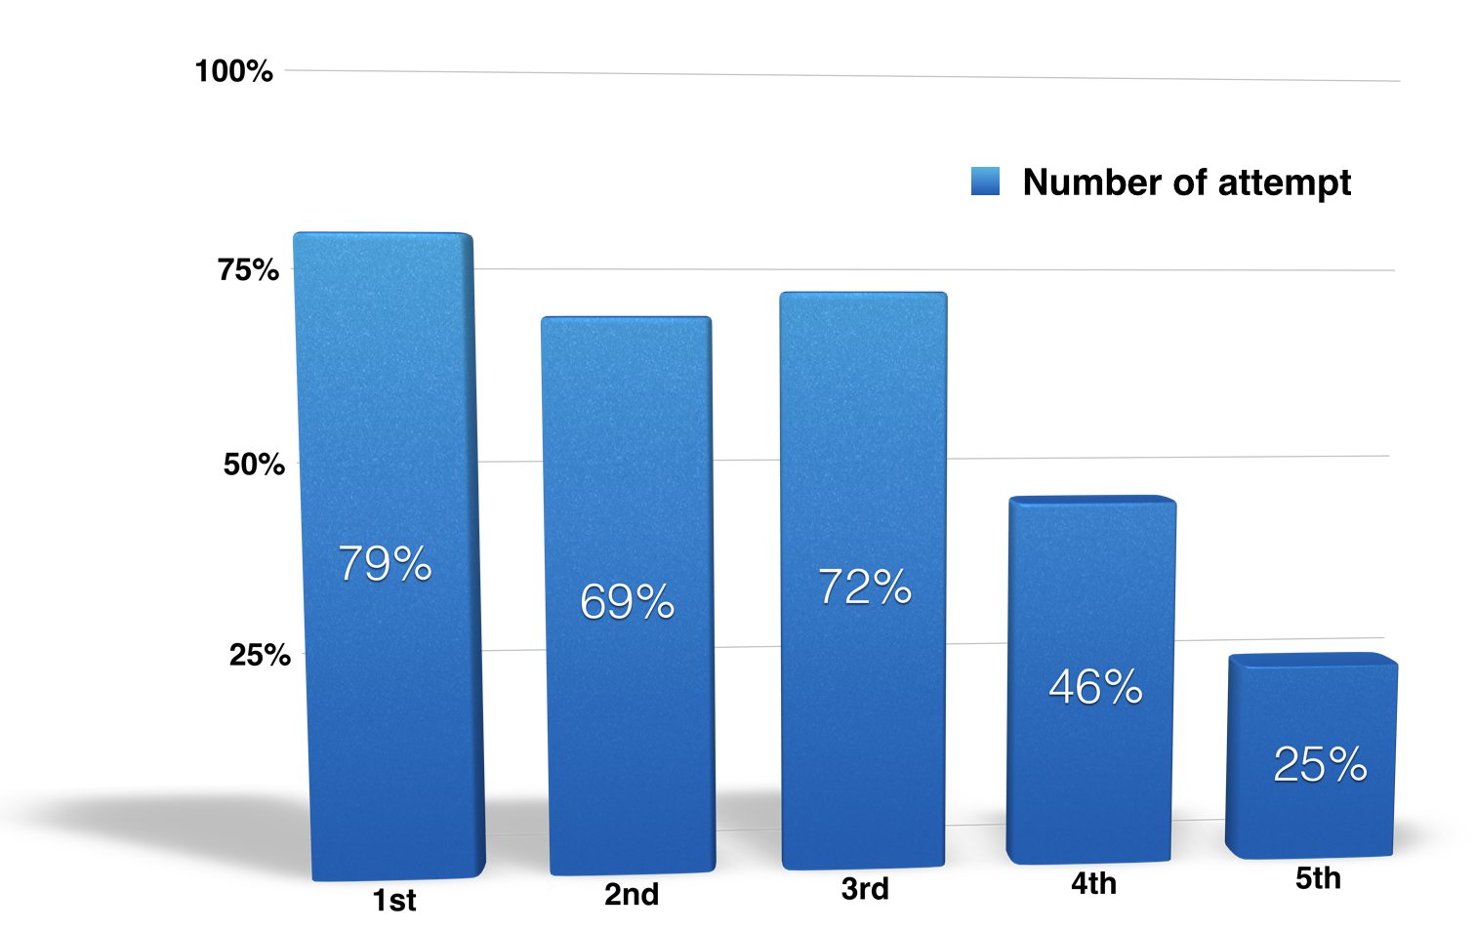
But what is so special about “two attempts”? Well, for many years there has been a consistent pattern in the exam results. The percentage of candidates who satisfy an exam area steadily declines with each subsequent attempt. These statistics from a recent round of exams are fairly typical. As a whole, almost 80% of candidates writing an exam for the first time satisfied the requirement in that area. For those retaking an exam, the satisfactory rate dropped about 10%. While the rate increased slightly for those taking an exam a third time, we will want to look at that number a bit more closely. By the time one reaches the fourth attempt fewer than half of candidates satisfy the requirement, and for fifth attempts and higher only a quarter of candidates satisfy the requirement.
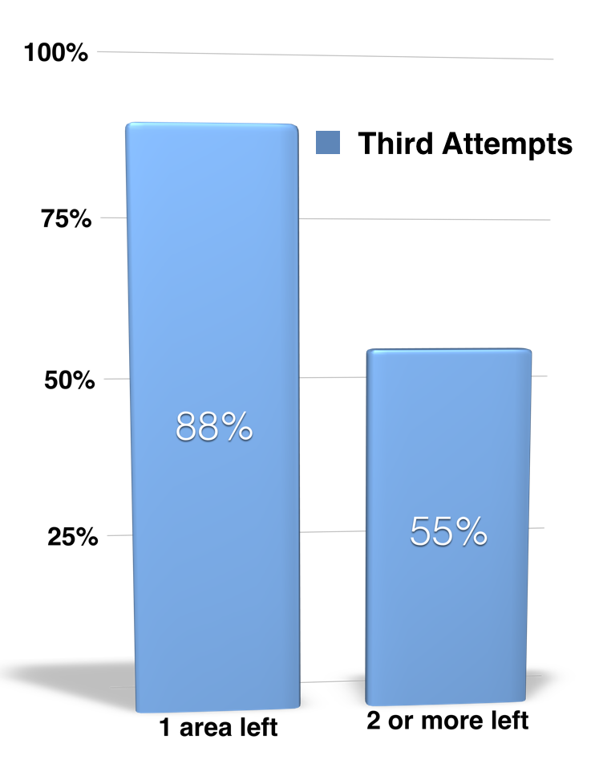
Looking more closely at those third attempts, for candidates repeating one area a third time but having already satisfied the other three exam areas, their satisfactory rate was just below 90%. If they had satisfied no more than two other areas, their satisfactory rate was just over half. These statistics show that for properly prepared candidates who have not satisfied at least three exam areas after two attempts, the problem may reside in the standard examination process itself.
Yet for some candidates it will be clear even before the first exam is taken that a timed, essay examination will not provide them an appropriate means for demonstrating their ministry competencies to others, even if provided with the opportunity to expand upon their responses through a structured oral examination component. For that reason the Book of Order also permits consideration of “alternate means” when there is evidence that it is the examination structures themselves that are preventing the demonstration of the required competencies. How might a presbytery’s committee make such a determination? Working with groups within the church who advocate for disability concerns, the following guidelines have been developed to help make such a determination.
- The candidate should submit documentation from a licensed professional who is qualified to make such assessments.
- The documentation should present a diagnosis that pertains directly to test-taking ability that is clear and specific about both the causes of the difficulty and what steps can be taken that would permit the candidate to demonstrate competency in the areas covered by the examinations.
- This assessment should have been recently completed so that it relates to the candidate’s current status, and thus no more than five years old.
- The accommodations required for the examination must be reasonable within a ministry context; that is, the candidate would be able to follow the same practice in their ministry without diminishing its effectiveness.
The final decision regarding the appropriateness of such accommodations resides with the presbytery itself and not with the committee overseeing preparation of its candidates. Any alternative assessment to the standard examination process requires a three-fourths vote of the presbytery. In approving the exception, the presbytery must also approve the “alternate means” that will be used to demonstrate competence in the affected examination areas. Both the reasons for and the alternate means themselves must be recorded in the presbytery’s minutes and communicated to any other presbytery considering either assuming the candidate’s care or proceeding to examine the candidate for ordination once a call is pending (G-2.0610).
Some care must be exercised, then, in crafting the motion to be considered by the presbytery. It should clearly include each of the following points:
- The specific reason for requesting an alternate means of assessment.
- The proposed process for assessing the candidate’s competency in the required areas.
- The source of any materials such as questions, case studies, etc., to be used in the assessment.
- An indication of who will administer and evaluate the results of the alternate means assessment.
When considering possible alternate means of assessment, the presbytery’s committee will want to maintain integrity with the standard examinations. The point is to provide an opportunity to demonstrate the required competencies for ministry, not alternative competencies. The alternate means, then, should have the same purpose as the standard exams and have the same level of difficulty relative to the ministry competencies required of those beginning ministry.
In short, alternate means recommendations are about changing the method of assessment not the competencies being assessed. The presbytery’s committee needs to be sure that the candidate is clear about what the alternative process will involve and what accommodations are—and are not—being provided. Any approved method of assessment must assure all work being evaluated is the candidate’s own. Working with the candidate, the committee should assure the availability of any necessary equipment or setting required by the alternate means.
In keeping with the principle of “blind review,” the nature of any disability should not be disclosed to those charged with evaluating the alternate means to the degree possible. Their evaluations need to be made in a context that simulates the conditions of ministry with those who will be unaware of such conditions when they first encounter the person in a ministry context. Remember: the purpose of alternate means of assessment is to make accommodations to provide for the demonstration of the candidate’s level of competency, not to assure a satisfactory evaluation. Presbyteries are not to waive any requirements or lower any standards of competency required by the Book of Order.
Keeping these principles in mind, committees are encouraged to be as creative as required in designing alternative means. Once the decision is made that an alternative is necessary, don’t just substitute an oral response to standard questions rather than written responses if something more is required. Here are some possible models for alternate means assessment to consider.
For the exegesis exam, prescribe a Bible study setting requiring treatment of a specific text. Give that information to both the candidate and the evaluators four to five days before the assessment. At the appointed time, have the candidate present the Bible study to the evaluators (playing the part of those who would hear the lesson in the prescribed setting), allowing them to raise questions both in response to what is in the lesson plan and based on their own preparatory study. That is, after all, what leading real Bible studies in a ministry context is like.
For the Polity exam, try a “mock session meeting.” One of the evaluators is designated the “clerk of session” for the assessment. The candidate, who in the scenario is a pastor recently returned from study leave, is to meet with the clerk about 30 minutes before the session meeting. At that time the clerk presents two or three issues that have arisen while the “pastor” was away. The candidate then uses that half hour to consult the Book of Order to prepare for these late additions to the agenda. Then have the candidate moderate the “session meeting” of evaluators as they deal with these issues. You might also require that the candidate open the meeting with a brief training for the evaluator “ruling elders” on the application of a principle of Presbyterian polity like those covered in the first question of the standard exam.
Role-playing assessments may also be used in alternate assessments in the areas of Theology and Worship as well. Begin with a “case study” that will also provide about 15 minutes for review of the Confessions before the candidate must respond—maybe a request from a worship committee for guidance on why a particular change in the service would be appropriate or not. Follow that “case study” with a couple more “role play” scenarios like those in the standard exams.
While the format of the standard ordination examinations may not be appropriate to everyone, they serve an important role within the overall preparation for ministry process. With careful work and cooperation between the presbytery’s committee and the candidate, it is possible to fulfill that purpose through special arrangements in the administration of the standard exams or through alternate means of assessment.
Keep in mind the following key points.
- The goal is to permit candidates to demonstrate their level of readiness to begin the ministry of Word and Sacrament to potential future peers in that ministry who have not previously been involved in their preparation.
- Every candidate, regardless of personal circumstances, is expected to have core competencies in the areas of Biblical Exegesis, Theology, Polity, and Worship and Sacraments.
- Any accommodations are not about lowering standards, but rather changing the means of assessment so candidates may adequately demonstrate their competencies for ministry.

